1. In tab ES->Product Snapshot, the tooltip between two periods in all the line charts is not consistent.

screenshot 1(mouse over the specific period):

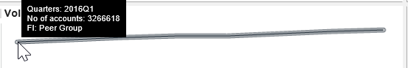

Screenshot 2(mouser over between two periods):

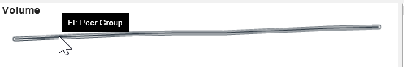

1. In tab Portfolio assessment->volume, the tooltip between two periods in the over time line charts is not consistent.

Screenshot 3( mouse over the specific period)

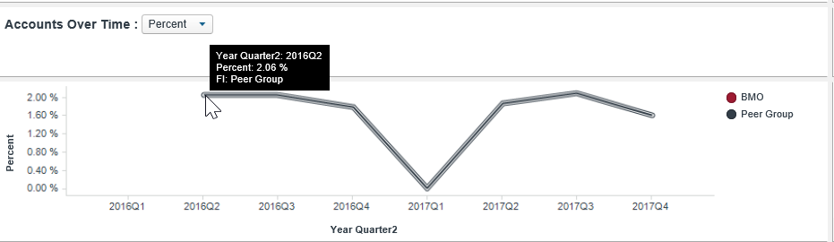

Screenshot 4(mouse over between two periods)

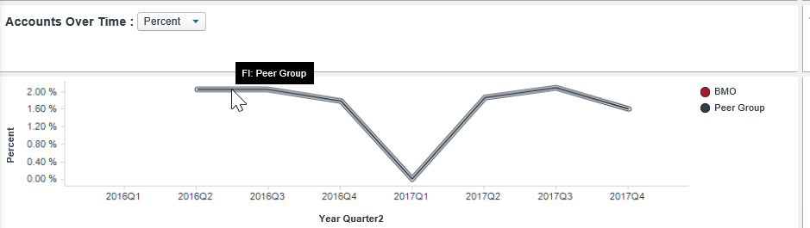

1. In tab portfolio assessment -> Utilization, Utilization Trend chart has additional description.

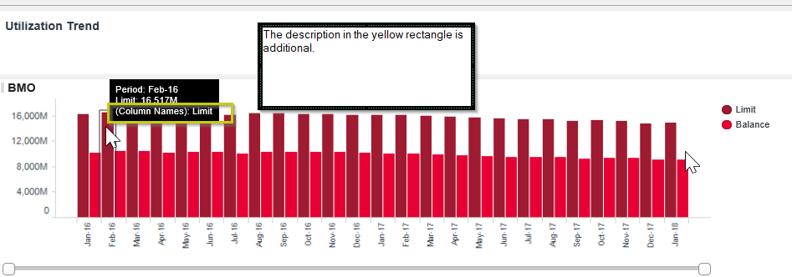

In the Same page , The tooltip also has additional information in the Utilization details Compared to Peer Risk distribution charts

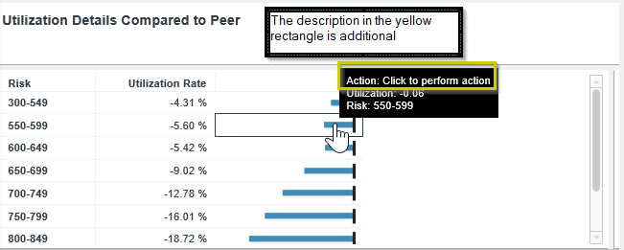

1. In tab portfolio assessment->delinquency

* In the Delinquent Balances chart, the header may need to change to Delinquency Balance in order to be consistent with other chart.

Also , the tooltip has additional information.

May need to change to for example

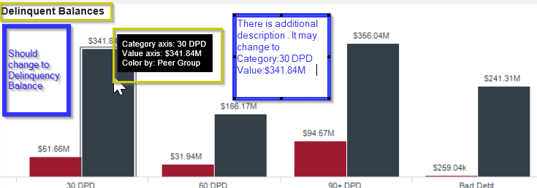

* Also in the delinquency Rate Over Time chart of the same page , , the tooltip between two periods is not consistent.

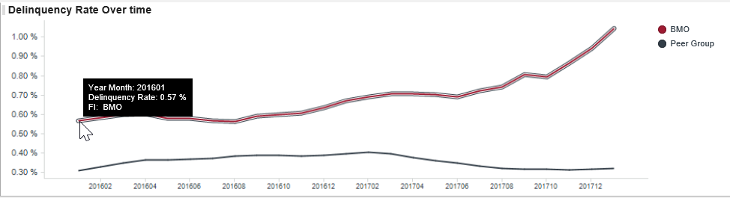

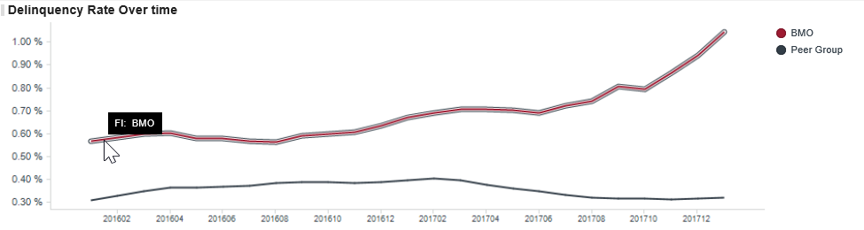

1. In tab portfolio assessment->Vintage

* Additional information in the tooltip in the line chart for all the measures, also the tooltip is not consistent when mouse move over the chart.

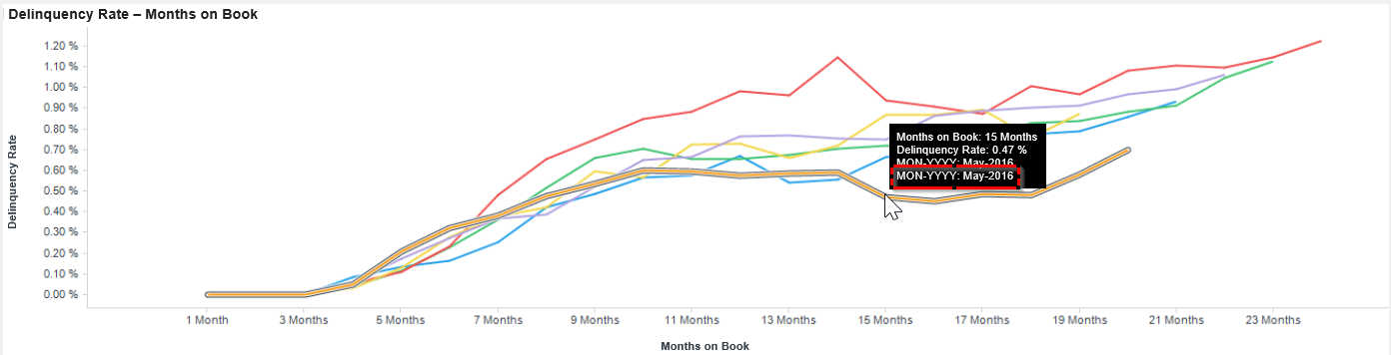

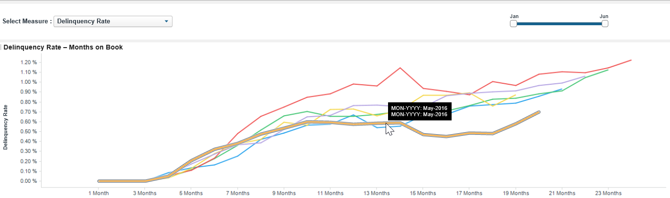

* In the detail page of this tab, the tooltip in the months on book chart has additional information and also not consistent when mouse move over the chart

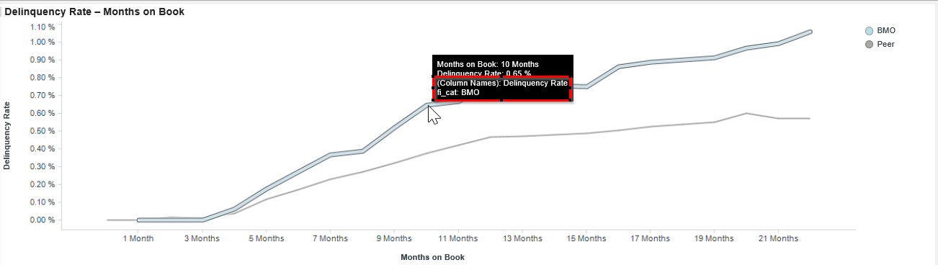

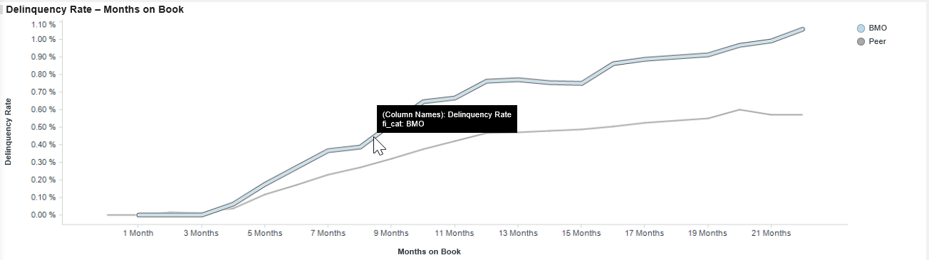

1. In tab portfolio assessment->CohortMatrix

Why only display information for vintage month between 201601 and 201606

* The tooltip is not consistent when mouse move over the chart.

Also fi_cat may change to FI since it will be consistent with the other charts

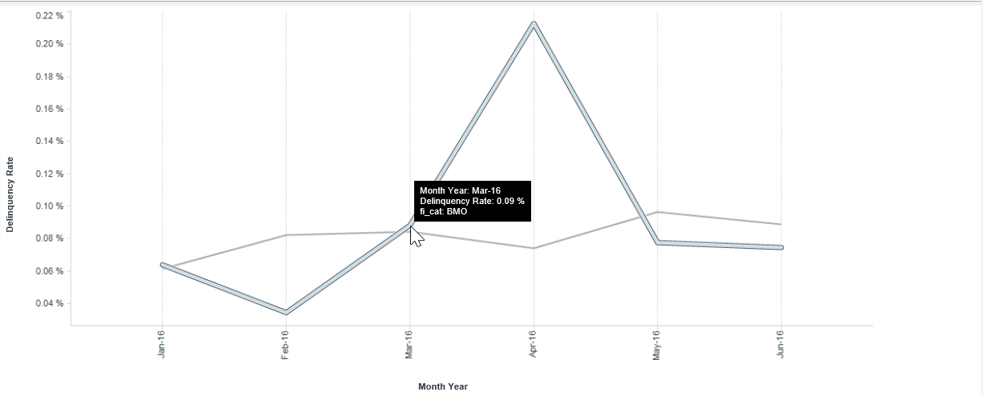

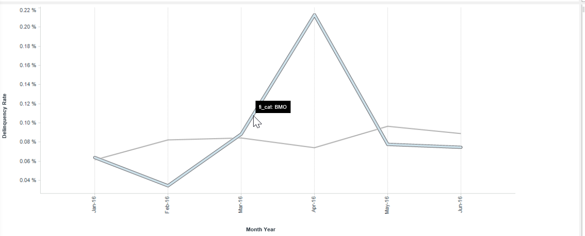

* In the same page , the the Comparsion chart , the vintage_month is not displayed in order.

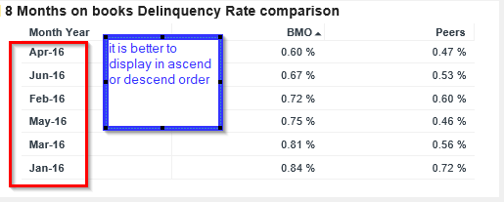

1. In tab Delinquency->Delinquency Trends, The tooltip is not consistent when mouse move over the chart.

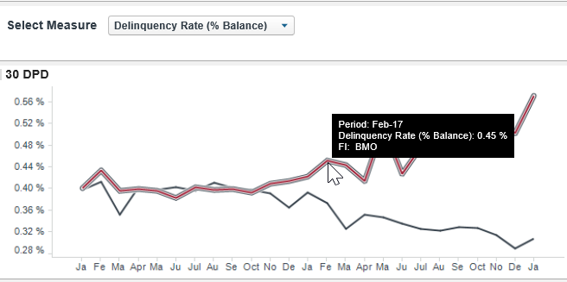

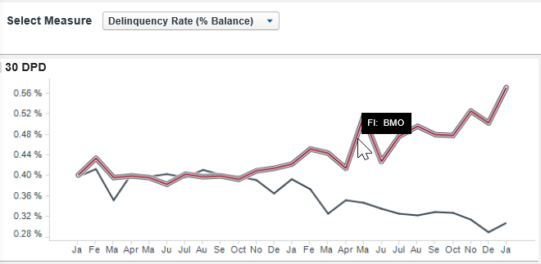

1. In the tab Delinquency->Roll Rates, the label may need to change to vertical direction since in the left side part of the label is not visible.

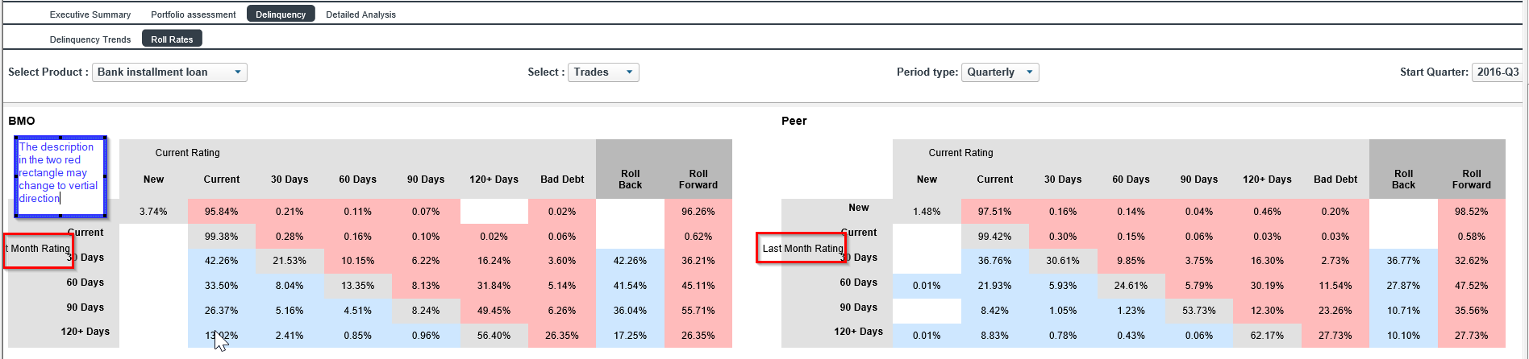

1. In the tab Detailed Analysis, the page doesn’t fit the screen size very well.

Screenshot in big screen ( The part inside the red rectangle is hard to view in my laptop)

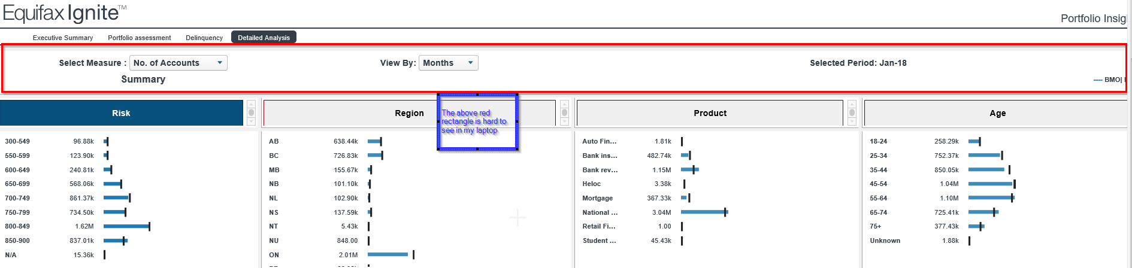

Screenshot in my laptop:

